ABSTRACT SUBMISSION

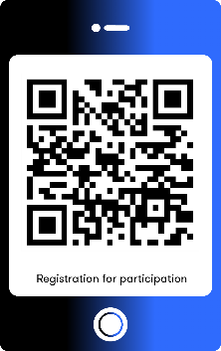
Abstracts will be published in the form of the conference proceedings. Abstracts must be prepared in Kazakh, Russian or English according to the template available at https://www.mathcongresskz2026.com/abstracts in LaTeX format, with a length of 1-2 pages in accordance with the abstract template. Abstracts should be submitted via the “Registration” section or by email no later than March 1, 2026.

Registration:
https://docs.google.com/forms/d/e/1FAIpQLSeEjir9oF6QL5Pp6IcZKDFWEZWdCgUrHJYfiTWMmOJR-KOxFg/viewform?usp=header

Your abstract will be reviewed by the organizers. Notification of acceptance or rejection will be sent by March 10, 2026.

If you have any questions regarding participation, please feel free to contact us by email at: math.congress-3@math.kz, math.congress@math.kz.

We kindly ask you to strictly follow the specified requirements. Abstracts that do not comply with the requirements will not be included in the book of abstracts.

